**Skill Week Test– Certified Ethical Hacker**

**Describe & Demonstrate Anon surf Tool**

Anon surf is a powerful privacy tool included in Kali Linux, designed to anonymize a user's internet activity by routing all network traffic through the Tor network. By doing so, it conceals the user's IP address and masks their identity, making it extremely difficult for external entities to track or monitor online activities.

**Steps to install**

1. Open Your Kali Linux Virtual Machine
2. Open Terminal
3. Run the below commands

cd temp

git clone https://github.com/Und3rf10w/kali-anonsurf.git

cd kali-anonsurf

sudo ./installer.sh

To start anon surf, run the command sudo anonsurf start

To stop anon surf, run the command sudo anonsurf stop

To check anon surf ip, run the command anonsurf myip

To restart anonsurf, run the command sudo anonsurf restart

**Implementation:**

Before Starting Anonsurf

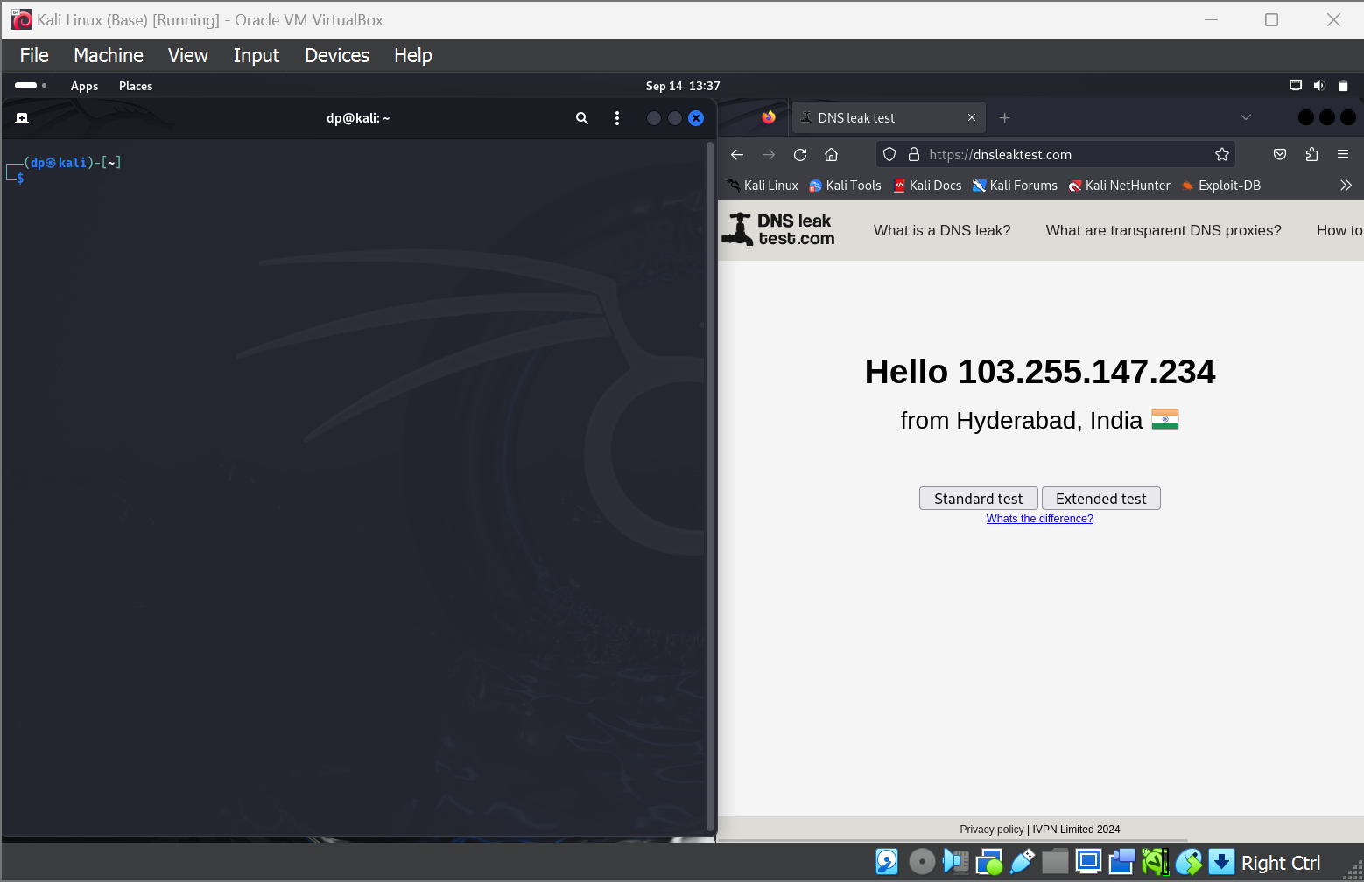

After starting Anonsurf

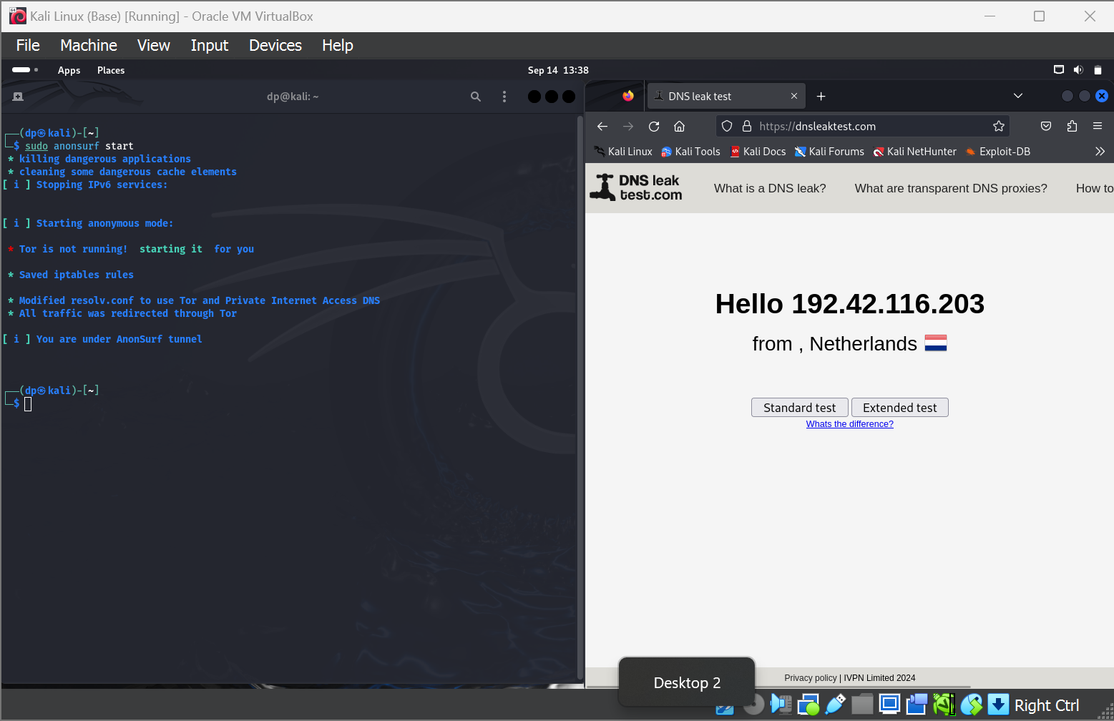

After Restarting AnonSurf  
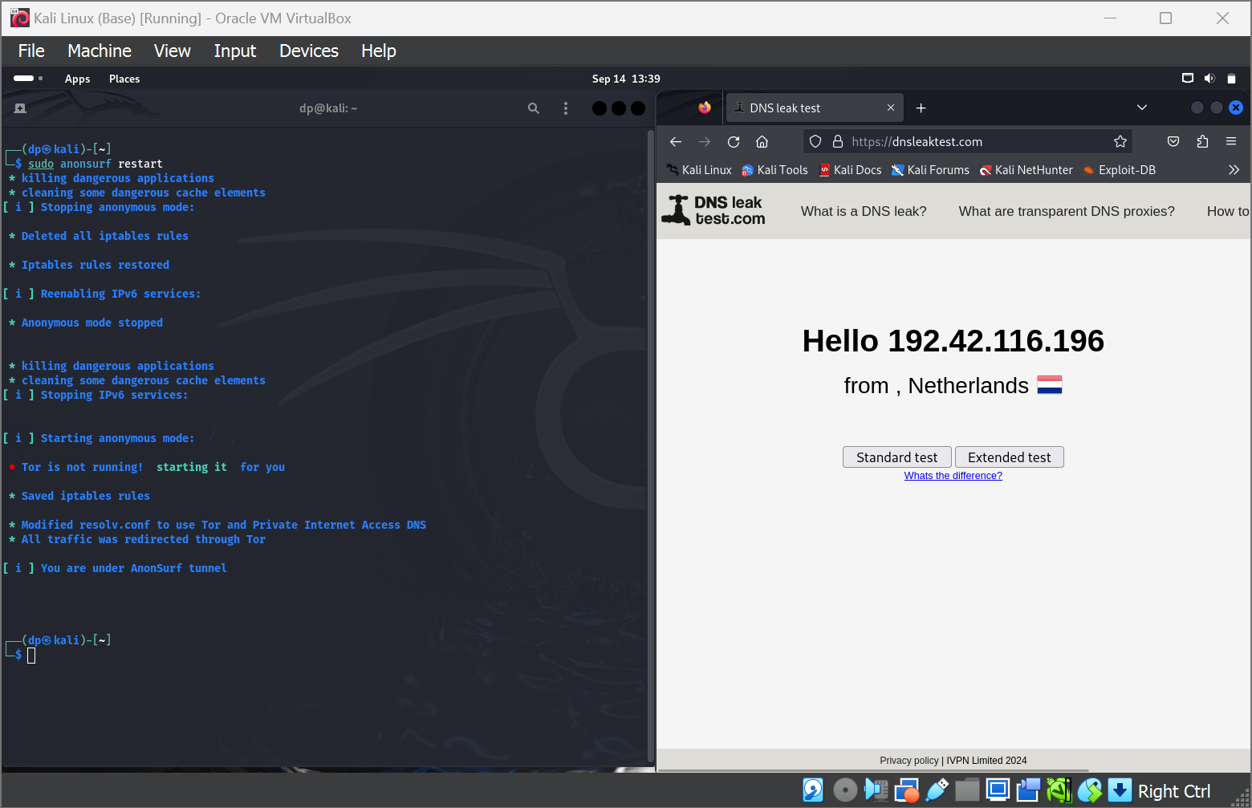

AnonSurf IP   
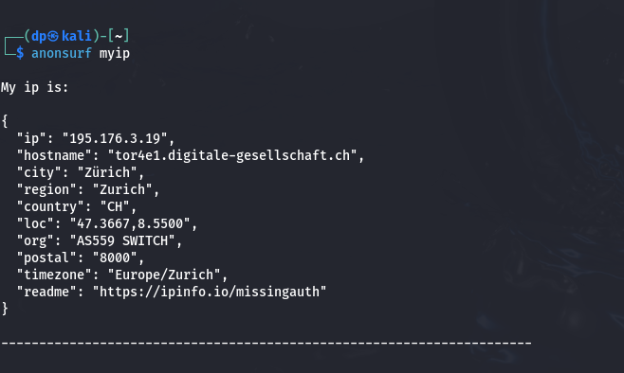

**Describe & Demonstrate the Harvester Tool**

TheHarvester is a versatile open-source intelligence (OSINT) tool built into Kali Linux, used for gathering and enumerating information about a target, such as email addresses, domain names, IP addresses, and subdomains. It operates by querying various public search engines, databases, and social media platforms, including Google, Bing, and Shodan, to retrieve valuable data on the target.

theHarvestor is already available in the tools when you install Kali Linux.

**Implementation**

We are scanning the domain www.klh.edu.in to look in all the sources that the tool uses.

theHarvester -d [www.klh.edu.in](http://www.klh.edu.in) -b all

